13 June 2025

Dear parent/carers,

There is no doubt that recruitment of teaching staff across the country is becoming ever more challenging. Teaching is an all consuming profession made up of highly qualified, caring and committed professionals who give us their all . They have always had many demands placed upon their time and energy - the advent of increased use of email and the impact of COVID seems to have sent some of these demands into overdrive in recent years … and yet they continue to care and do their best. I was struck many years ago about the potential number of interactions a teacher may undertake in one day - at least 1500. This includes decision making, questioning , pupil support, instruction, parental communications, collaborations and of course … marking! 

Aligned to this is all of the insane work of every adult in an educational community whose efforts underpin everything a school delivers. LSA’s , receptionists, finance roles, technicians, admin staff and student support workers all add value to the day to day running of a school (and in many cases keep the ship afloat!)

With that in mind Wednesday of next week is officially ‘THANK A TEACHER DAY’ - This day is about appreciating the hard work **of all those who help create an impact on children and young people across early years, schools, and colleges.** The work they do is vital to opening up opportunities for children and young people. It would be great to remind ourselves how valuable and much needed these professionals are. If you or your children would like to send a thank you to ANY member of our staff you can send a

[free personalised e-card](https://news.service.education.gov.uk/6432F95412DA5181E2B2D59CB2D739F69FFE54787F276AA4405D0D727F30DE2D/7B56C9C5BEB92B5F25BDA284A10610A3/LE35)

to express your gratitude. It's a simple way to make someone's day and acknowledge the vital work happening in education in your local school.

**REMINDER** : All Year 11 students who have accepted their conditional offer to JCS Sixth Form are reminded to confirm their attendance at our Induction Day by logging into their account on Applicaa by Monday 16 June. During the Induction Day on Friday 4 July students will find out about life in the sixth form, try taster lessons in their chosen subjects and discover more about the careers and next step opportunities that we offer. We warmly encourage all offer holders to attend. If your child is unable to attend, please email sixthformadmissions@johncolet.co.uk

Take care - Ian Brierly

**REMINDERS & NOTICES**

|  |
| --- |
| **\*\* PARENT ALERT \*\*** |

We have been alerted by some parents that an ex-pupil of the school is distributing vapes in the community . This may be taking place after school as students make their way home. We would urge you to check school bags/blazers etc for vapes and please to report anything untoward to us a.s.a.p.

**DATES FOR YOUR DIARY**

**FOCUS & Year 10 Work Experience week** - 23 -27 June

**Year 6 Induction Days**  - 1 & 2 July

**Year 12 Induction Day**  - 4 July

**Sports Day** - 8 July

**CAREERS**

**Work Experience**

We still have a number of our year 10 students looking for a work experience placement for 23rd-27th June. If you are able to offer a placement please contact Mrs Sinacore, our careers adviser at wex@johncolet.co.uk, we are particularly keen to find placements in construction, carpentry or sports related roles.

**CURRENT VACANCIES**

* Cover Supervisor
* Geography / Business Studies teacher

Please check our website for further details [here](https://www.johncolet.co.uk/about/vacancies/).

**SAFEGUARDING LEADS & INFORMATION**

If parents have any concerns about this practice or, believe that any young person at John Colet School might be at risk, then please do contact one of the members of our Safeguarding Team via - [safeguarding@johncolet.co.uk](mailto:safeguarding@johncolet.co.uk)

**YEAR 12 INDUCTION DAY - 4 JULY**

Year 11 students who have accepted their conditional offer to JCS Sixth Form are invited to our Sixth Form Induction Day on Friday 4 July. During this day students will find out about life in the sixth form, try taster lessons in their chosen subjects and discover more about the careers and next step opportunities that we offer. Students will be sent more information on the day by email over the next few weeks.

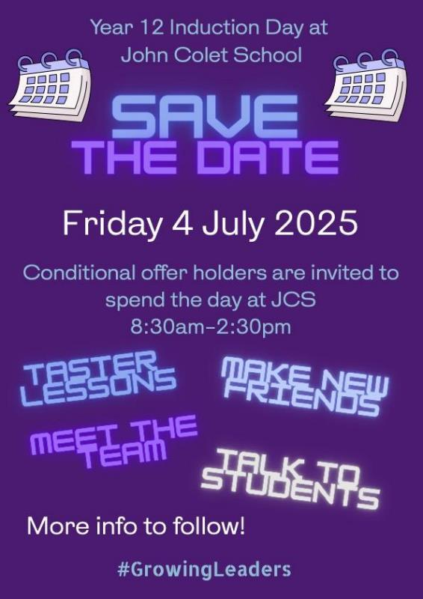

**PARENT SUPPORT : Click** [**HERE**](https://drive.google.com/file/d/1MragE3y-vzQ4IQIEt6IeXNBdJ4qFypAm/view?usp=drive_link) **for practical tips**



**TOOLED UP - PARENT SUPPORT**



The natural environment is precious to us all - being outdoors gives us an escape from the busy world of work and education, and offers our children new opportunities for learning and pleasure.

An increasing amount of **research confirms** what many parents and educators know intuitively: **spending time in natural spaces** and **exploring** the **outdoors** can **bring** real and lasting **benefits to wellbeing, self-esteem** and **social skills** development.

These Tooled Up resources will help children to explore, have fun and learn in natural spaces.

Our list of [**75 Things to Do Outside**](https://members.tooledupeducation.com/resource/activity/75-things-to-do-outside) is **packed with suggestions for primary-aged** children who need a little encouragement to step into the outside world! Why not set a challenge for your child to see how many they can complete?

This **downloadable guide** to[**Beach Science for Teens**](https://members.tooledupeducation.com/resource/activity/beach-science-for-teens) offers **enriching, challenging activities and concepts** that are perfect **for older children** visiting the coast.

We all want our children to have an enjoyable, but safe time in the sun. **Sun safety** is an **essential** skill **for all children to learn**, especially when they’re growing into independence. This resource on [**Keeping Children and Teens Safe in the Sun**](https://members.tooledupeducation.com/resource/article/keeping-children-and-teens-safe-in-the-sun) **was** **created by a Consultant Dermatologist** and will help you ensure your family are protected on scorching summer days.



**COMMUNITY SUPPORT / ACTIVITIES**

