6 June 2025
Dear parent/carers,

Cultural Day Food Festival – Parent Participation Invitation
We are excited to announce our upcoming Cultural Day Food Festival on Wednesday, 3rd July, and we warmly invite you to join us in celebrating the rich tapestry of cultures within our school community.
Event Details:
- Date: Wednesday, 3rd July
- Time: 10:55 am - 1.55 pm
- Location: Our School Hall
To make this event truly special, we are seeking food donations from families to create a diverse and inclusive "potluck" dinner. We encourage you to contribute dishes that reflect your cultural heritage, family traditions, or simply foods that bring joy to your home. Whether it's a beloved family recipe, a traditional dish from your culture, or a favourite comfort food, your contribution will add to the vibrant tapestry of our celebration.
Food Donation Guidelines:
- All food donations should be brought to school on the morning of Wednesday, 3rd July. Please ensure that all dishes are nut-free and clearly labelled with a list of ingredients to accommodate dietary restrictions.
- If possible, provide serving utensils for your dish. Please label with your child’s name so we can make sure all items from home do return home.
This festival is not only an opportunity to share delicious food but also to create lasting memories with your children and fellow families. We hope to foster a sense of belonging and appreciation for the diverse backgrounds that make our school community unique.
If you would like to contribute a dish or assist in any other way, please complete the following form and return it by Friday 20th June. Should you have any questions or require further information, feel free to contact lparrott@johncolet.co.uk
Thank you for your support in making this event a memorable and meaningful experience for all.
Warm regards → Leanne Parrott and the Equality and Diversity school council team
REMINDERS & NOTICES
** PARENT ALERT **

We have been alerted by some parents that an ex-pupil of the school is distributing vapes in the community . This may be taking place after school as students make their way home. We would urge you to check school bags/blazers etc for vapes and please to report anything untoward to us a.s.a.p.

DATES FOR YOUR DIARY

PGL Parents evening - 11 June
FOCUS & Year 10 Work Experience week - 23 -27 June
Year 6 Induction Days - 1 & 2 July
Year 12 Induction Day - 4 July
Sports Day - 8 July

CAREERS

Work Experience
We still have a number of our year 10 students looking for a work experience placement for 23rd-27th June. If you are able to offer a placement please contact Mrs Sinacore, our careers adviser at wex@johncolet.co.uk, we are particularly keen to find placements in construction, carpentry or sports related roles.

CURRENT VACANCIES

- Cover Supervisor
- Geography / Business Studies teacher

Please check our website for further details here.

SAFEGUARDING LEADS & INFORMATION
If parents have any concerns about this practice or, believe that any young person at John Colet School might be at risk, then please do contact one of the members of our Safeguarding Team via - safeguarding@johncolet.co.uk

YEAR 12 INDUCTION DAY - 4 JULY
Year 11 students who have accepted their conditional offer to JCS Sixth Form are invited to our Sixth Form Induction Day on Friday 4 July. During this day students will find out about life in the sixth form, try taster lessons in their chosen subjects and discover more about the careers and next step opportunities that we offer. Students will be sent more information on the day by email over the next few weeks.
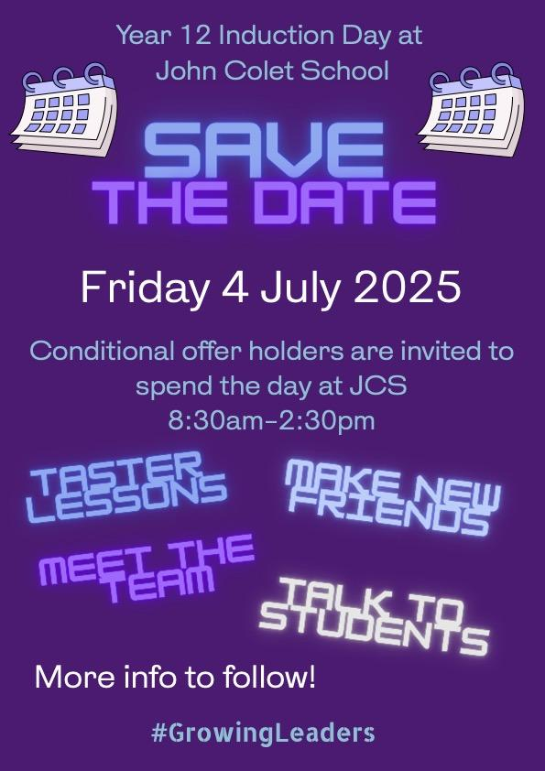

PARENT SUPPORT : Click HERE for practical tips

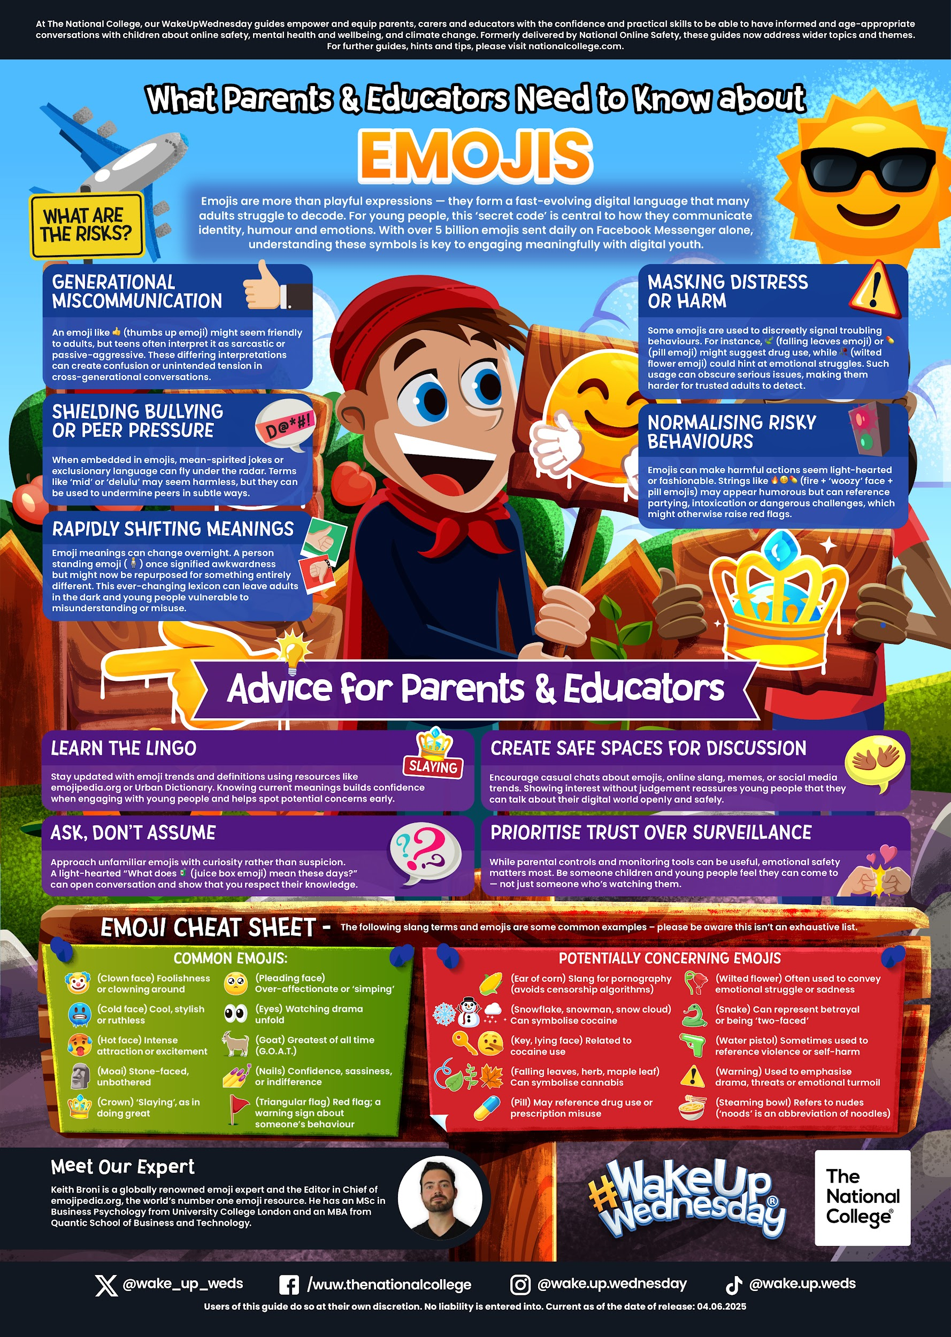

TOOLED UP - PARENT SUPPORT

The natural environment is precious to us all - being outdoors gives us an escape from the busy world of work and education, and offers our children new opportunities for learning and pleasure.
An increasing amount of research confirms what many parents and educators know intuitively: spending time in natural spaces and exploring the outdoors can bring real and lasting benefits to wellbeing, self-esteem and social skills development.
These Tooled Up resources will help children to explore, have fun and learn in natural spaces.
Our list of 75 Things to Do Outside is packed with suggestions for primary-aged children who need a little encouragement to step into the outside world! Why not set a challenge for your child to see how many they can complete?
This downloadable guide to Beach Science for Teens offers enriching, challenging activities and concepts that are perfect for older children visiting the coast.
We all want our children to have an enjoyable, but safe time in the sun. Sun safety is an essential skill for all children to learn, especially when they’re growing into independence. This resource on Keeping Children and Teens Safe in the Sun was created by a Consultant Dermatologist and will help you ensure your family are protected on scorching summer days.

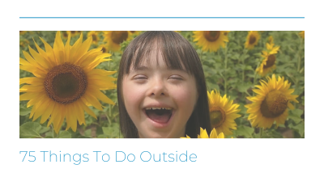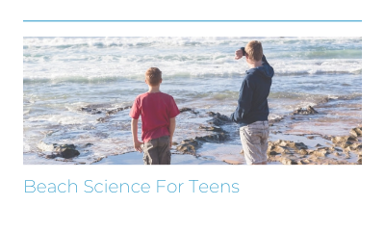
COMMUNITY SUPPORT / ACTIVITIES
