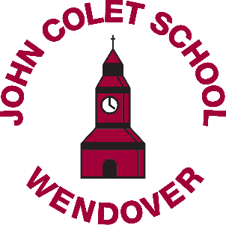

Committed to Excellence

Classroom/Learning Support Assistant
Fixed Term and Permanent Positions
Part time considered
Starting September 2018

38 weeks a year (plus 2 INSET days on a timesheet basis)
Salary Range 1b ISN6.
Actual salary £7.90 per hour (FTE £15,235)

Up to 34.5 hours per week, between 8.20am – 4pm

Do you want to work with young people and help them to fulfill their potential? Do you want to make a difference?

Are you looking for paid GAP year work or term-time only to fit around your family?

Are you considering becoming a teacher but want to see if it is a career you would enjoy before committing to teacher training?

We are looking for enthusiastic and committed people to join our friendly Learning Support Team. The team works with students across the age range (11-18) in the classroom under the guidance of the teacher. Reliability, patience, flexibility and a good general knowledge are essential. Candidates must have a minimum of Mathematics, English and a science GCSE level at grade C or above and be prepared to work across the entire curriculum. Some experience of working with secondary age students is desirable but relevant training will be given.

Previous applicants need not apply.

Closing date: 9am Monday, 24 September 2018 nterview date: tbc

Please email completed application forms (form attached) to office@johncolet.co.uk

The John Colet School takes the safeguarding and wellbeing of students seriously and this post is subject to an enhanced DBS and Qualifications check

