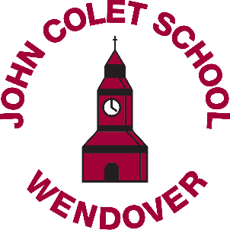

Committed to Excellence
Classroom/Learning Support Assistants
Permanent or Fixed Term positions available to start as soon as possible
£9.01 per hour
(FTE £17,383)

Term time only (Plus up to 2 INSET days on a timesheet)
Between 28.1 and 35.25 hours per week, to be worked between
8.30am – 4pm; 8.15am on Wednesdays
(different start and end times will be considered for the right candidate)

Why would you not want to work in an oversubscribed, Ofsted graded ‘GOOD’ school with friendly staff and a great school community? Find out what it is like to know that you have made a difference when you leave work each day and what really happens in a school staff room.

You don’t need a degree or do years of study to feel good about your work and have up to 14 weeks holiday a year.

Are you looking for work to it in with your family life? Have you finished your degree and are not sure of your next step? Are you considering becoming a teacher but want to see if it is a career you would enjoy before committing to teacher training (we may also be able to offer teaching training through ASTRA Learning Alliance)?

We are looking for enthusiastic and friendly people to join our Learner Support Team who work with students across the age range (11-18) with physical and/or learning disabilities in the classroom under the guidance of the teacher or in the dedicated Learner Support Department. Reliability, patience, flexibility and a good general knowledge are essential and all necessary training is provided.

Candidates must have a minimum of Mathematics, English and a science GCSE level at grade C or equivalent.

John Colet School reserves the right to either extend or reduce the vacancy window to that advertised depending on volume of applications received. We would therefore recommend early return of completed application forms to avoid disappointment.

Please email completed application forms (form attached) to office@johncolet.co.uk
The John Colet School takes the safeguarding and wellbeing of students seriously and this post is subject to an enhanced DBS and Qualifications check

